EXPERIMENT: 6
DATE:16.07.26
Vacuum Cleaner Problem

Aim:
To write a Python program to implement the Vacuum Cleaner Problem.

Algorithm:

- Read the status of Room A and Room B (Dirty/Clean).
- Assume the vacuum cleaner starts in Room A.
- Check the current room:
- If the room is dirty, clean it.
- If the room is already clean, move to the next room.
- Repeat the process until both rooms are clean.
- Display the action performed and the final state of the rooms.

Program:

roomA = input("Enter the status of Room A (Dirty/Clean): ").capitalize()
roomB = input("Enter the status of Room B (Dirty/Clean): ").capitalize()
location = "A"
print("\nVacuum Cleaner Starts in Room A\n")
while True:
if location == "A":
if roomA == "Dirty":
print("Room A is Dirty -> Cleaning Room A")
roomA = "Clean"
else:
print("Room A is already Clean")
print("Moving to Room B\n")
location = "B"
else:
if roomB == "Dirty":
print("Room B is Dirty -> Cleaning Room B")
roomB = "Clean"
else:
print("Room B is already Clean")
break
print("\nFinal Status")
print("Room A :", roomA)
print("Room B :", roomB)
if roomA == "Clean" and roomB == "Clean":
print("\nGoal State Achieved")

Output:
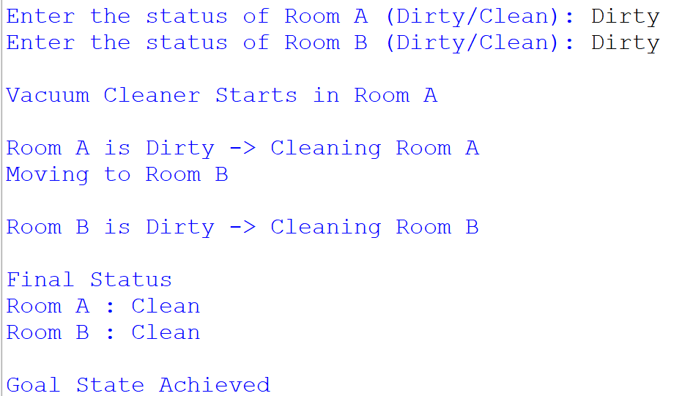

Result:

Thus, the Python program to implement the Vacuum Cleaner Problem was successfully executed, and both rooms were cleaned to achieve the goal state.

